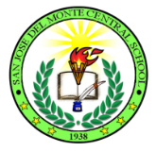
Republic of the Philippines
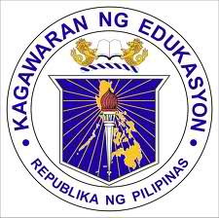
Department of Education
Region III
Division of City Schools
District of San Jose Del Monte West
SAN JOSE DEL MONTE CENTRAL SCHOOL
City of San Jose Del Monte

September 10, 2017

School Memorandum
No. 11, s. 2017

SCHOOL LEARNING ACTION CELL (SLAC) on
Simple Techniques in Guidance and Counselling and Updates in School Based Management ( SBM )

To: All San Jose Del Monte Central School Teachers

- There will be a School Learning Action Cell (SLAC) for Teachers on September 22, 2017, 1:00- 5:00 P.M. at San Jose Del Monte Central School Conference Hall.

- The objectives of the training are as follows:

- updates the teachers in guidance and counselling, songs for the learners and basic hand writing techniques
- inform teachers on the quality standards and indicators for Philippine Accreditation System for Basic Education System ( PASBE )
- Expenses like training materials and snacks shall be charge on School Fund- Canteen.

- In connection with this, participants are instructed to be in the venue at exactly one o’clock in the afternoon.

- Enclosure no. 1 contains the matrix of activities and the working committee.

- Wide dissemination of this memorandum is highly appreciated.

NERLIZA C. MIRANDA
Principal III

