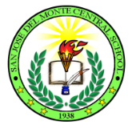
Republic of the Philippines

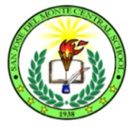
DEPARTMENT OF EDUCATION
Region III
Division of City Schools
District 6
sAN JOSE DEL MONTE CENTRAL SCHOOl
City of San Jose del Monte,Bulacan

October 3, 2017
In Service Training (INSET) for Teachers
School Memorandum
No. 12, s. 2017

To: All San Jose del Monte Central School Teachers

- There will be an In Service Training (INSET) for teachers on October 23-27, 2017, 8:00-5:00 P.M. at San Jose del Monte Central School Conference Hall.

- The objectives of the training are as follows:

2.1. Realize the teachers role in Getting to Know K-12 Learners Better ,
2.2. Strengthen their Teaching Knowledge, Skills and Techniques,
2.3.Develop teachers creativity in preparation and use of Instructional Materials.
2.4. Revisit Teaching-Learning Process.

- Expenses like training materials and snacks shall be charged against Maintenance and Other Operating Expenses (MOOE) and Canteen Fund.

- In this connection, participants are instructed to be in the venue at exactly eight o’clock in the morning.

- Enclosure no.1 contains the Matrix of Activities and the working committees.

- Wide dissemination of this memorandum and attendance of all concerned is highly expected.

NERLIZA C. MIRANDA
Principal III

